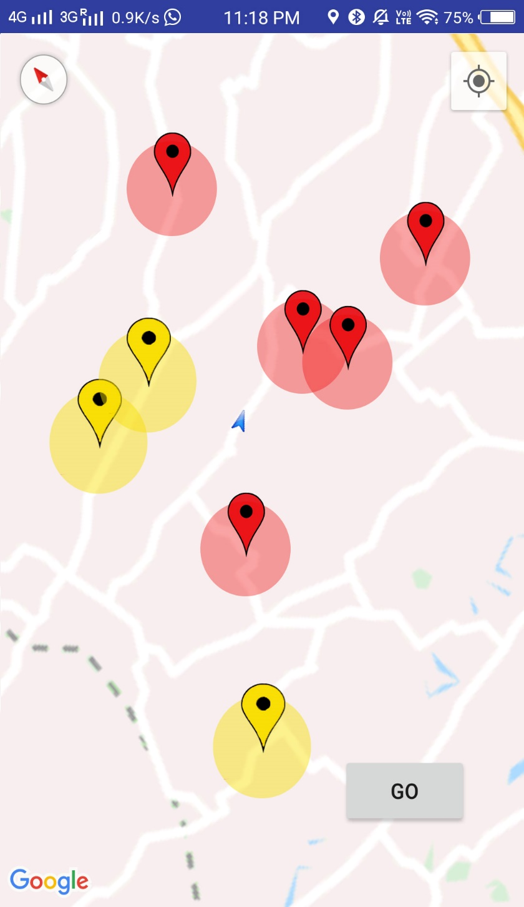

* We designed our map with various patterns.
* For example,
* **Red** zones indicates ACCIDENT PRONES
* **Yellow** zones indicates CONSTRUCTION WORKS, other activities etc .
* Like there are more zones indicating different Public and private activities.
* When User enters any of the above zones , they will be warned by a notification to prefer an other road.
* This app also had a feature that allows the user device to update the server with real time data’s such as accident and other warnings which in turn updates other user’s devices (using CAS Alert systems).